**Logistic Regression**

**1. Data Exploration:**

**a. Load the dataset and perform exploratory data analysis (EDA).**

**b. Examine the features, their types, and summary statistics.**

**c. Create visualizations such as histograms, box plots, or pair plots to visualize the distributions and relationships between features.**

**Analyze any patterns or correlations observed in the data.**

**Answer:**

PS D:\python apps> & "D:/python apps/.venv/Scripts/python.exe" "d:/python apps/titanic_logreg_full.py"

Using TRAIN_PATH = D:\DATA SCIENCE\ASSIGNMENTS\7 logistic regression\Logistic Regression\Titanic_train.csv

Using TEST_PATH = D:\DATA SCIENCE\ASSIGNMENTS\7 logistic regression\Logistic Regression\Titanic_test.csv

=== TRAIN HEAD ===

PassengerId Survived Pclass

Name Sex Age SibSp Parch Ticket Fare Cabin Embarked

1 0 3 Braund, Mr. Owen Harris male 22.0 1 0 A/5 21171 7.2500 NaN S

2 1 1 Cumings, Mrs. John Bradley (Florence Briggs Thayer) female 38.0 1 0 PC 17599 71.2833 C85 C

3 1 3 Heikkinen, Miss. Laina female 26.0 0 0 STON/O2. 3101282 7.9250 NaN S

4 1 1 Futrelle, Mrs. Jacques Heath (Lily May Peel) female 35.0 1 0 113803 53.1000 C123 S

5 0 3 Allen, Mr. William Henry male 35.0 0 0 373450 8.0500 NaN S

=== TRAIN INFO ===

<class 'pandas.core.frame.DataFrame'>

RangeIndex: 891 entries, 0 to 890

Data columns (total 12 columns):

# Column Non-Null Count Dtype

--- ------ -------------- -----

0 PassengerId 891 non-null int64

1 Survived 891 non-null int64

2 Pclass 891 non-null int64

3 Name 891 non-null object

4 Sex 891 non-null object

5 Age 714 non-null float64

6 SibSp 891 non-null int64

7 Parch 891 non-null int64

8 Ticket 891 non-null object

9 Fare 891 non-null float64

10 Cabin 204 non-null object

11 Embarked 889 non-null object

dtypes: float64(2), int64(5), object(5)

memory usage: 83.7+ KB

None

Summary statistics:

count unique ... 75% max

PassengerId 891.0 NaN ... 668.5 891.0

Survived 891.0 NaN ... 1.0 1.0

Pclass 891.0 NaN ... 3.0 3.0

Name 891 891 ... NaN NaN

Sex 891 2 ... NaN NaN

Age 714.0 NaN ... 38.0 80.0

SibSp 891.0 NaN ... 1.0 8.0

Parch 891.0 NaN ... 0.0 6.0

Ticket 891 681 ... NaN NaN

Fare 891.0 NaN ... 31.0 512.3292

Cabin 204 147 ... NaN NaN

Embarked 889 3 ... NaN NaN

[12 rows x 11 columns]

Missing values (train):

PassengerId 0

Survived 0

Pclass 0

Name 0

Sex 0

Age 177

SibSp 0

Parch 0

Ticket 0

Fare 0

Cabin 687

Embarked 2

dtype: int64

Creating EDA plots (saved to ./plots/)...

EDA plots saved. Check the ./plots folder.

Modeling features preview:

Pclass Sex Age SibSp ... Fare Embarked Title HasCabin

0 3 male 22.0 1 ... 7.2500 S Mr 0

1 1 female 38.0 1 ... 71.2833 C Mrs 1

2 3 female 26.0 0 ... 7.9250 S Miss 0

3 1 female 35.0 1 ... 53.1000 S Mrs 1

4 3 male 35.0 0 ... 8.0500 S Mr 0

[5 rows x 9 columns]

Train/Valid split sizes: (712, 9), (179, 9)

=== Evaluation on Validation ===

Accuracy: 0.8324

Precision: 0.8000

Recall: 0.7536

F1-score: 0.7761

ROC-AUC: 0.8718

Classification report:

precision recall f1-score support

0 0.85 0.88 0.87 110

1 0.80 0.75 0.78 69

accuracy 0.83 179

macro avg 0.83 0.82 0.82 179

weighted avg 0.83 0.83 0.83 179

5-fold CV ROC-AUC scores: [0.90217391 0.86804813 0.84859626 0.85614973 0.89436245]

Mean CV ROC-AUC: 0.8739 (+/- 0.0210)

Feature names after preprocessing (approx):

['Age', 'SibSp', 'Parch', 'Fare', 'Sex_female', 'Sex_male', 'Embarked_C', 'Embarked_Missing', 'Embarked_Q', 'Embarked_S', 'Title_Master', 'Title_Miss', 'Title_Mr', 'Title_Mrs', 'Title_Rare', 'HasCabin_0', 'HasCabin_1', 'Pclass']

Number of features (coeffs): 18

Number of feature names: 18

Top coefficients (by absolute value):

feature coefficient abs_coef

Title_Master 1.393461 1.393461

Sex_female 1.208548 1.208548

Title_Mr -1.121133 1.121133

HasCabin_1 0.922405 0.922405

Title_Mrs 0.833881 0.833881

Pclass -0.663601 0.663601

Embarked_Q 0.504390 0.504390

SibSp -0.430494 0.430494

Age -0.403131 0.403131

Sex_male -0.337170 0.337170

Title_Rare -0.299027 0.299027

Embarked_C 0.298267 0.298267

Parch -0.249520 0.249520

Fare 0.139413 0.139413

Embarked_Missing 0.121883 0.121883

Trained pipeline saved to model.joblib

Predictions for provided test file saved to D:\DATA SCIENCE\ASSIGNMENTS\7 logistic regression\test_predictions.csv

**2. Data Preprocessing:**

**a. Handle missing values (e.g., imputation).**

**b. Encode categorical variables.**

**Answer :**

### Handling Missing Values (Imputation)

Inside the **preprocessing pipeline**:

numeric_transformer = Pipeline(steps=[

('imputer', SimpleImputer(strategy='median')), # fills missing Age, Fare

('scaler', StandardScaler()),

])

* For **numerical columns** (Age, SibSp, Parch, Fare) → missing values are replaced with the **median** of that column.
* For **categorical columns** (Sex, Embarked, Title, HasCabin) → missing values are handled by:

categorical_transformer = Pipeline(steps=[

('imputer', SimpleImputer(strategy='most_frequent')), # fills missing Embarked

('onehot', OneHotEncoder(handle_unknown='ignore', sparse_output=False)),

])

That fills missing with the **most frequent value** (mode).

* Cabin was turned into a binary flag (HasCabin) earlier — so missingness is directly captured as 0.
* Embarked had 2 missing values; they were filled with 'Missing' before the pipeline even ran.

So yes, **all missing values are handled automatically**.

### b. Encoding Categorical Variables

Also in the **categorical transformer**:

OneHotEncoder(handle_unknown='ignore', sparse_output=False)

* Converts Sex, Embarked, Title, HasCabin into dummy variables (0/1).
* Keeps Pclass numeric (treated as ordinal).

This means model sees only **clean numeric features**.

Conclusion:  
script **does complete preprocessing**:

* Missing numeric → filled with median
* Missing categorical → filled with most frequent (or explicitly 'Missing')
* Categorical variables → one-hot encoded

**3. Model Building:**

**a. Build a logistic regression model using appropriate libraries (e.g., scikit-learn).**

**b. Train the model using the training data.**

**Answer:**

**Build a Logistic Regression Model**

The script sets up a **pipeline** that chains preprocessing + logistic regression:

clf = Pipeline(steps=[

('preprocessor', preprocessor),

('clf', LogisticRegression(

solver='liblinear',

random_state=42,

max_iter=1000

))

])

* LogisticRegression comes from **scikit-learn**.
* Solver = "liblinear" (a good choice for small to medium datasets like Titanic).
* max_iter=1000 makes sure the optimization fully converges.
* Using a pipeline means preprocessing (imputation + encoding) is applied automatically during training and prediction.

**b. Train the Model Using Training Data**

Later in the script, the pipeline is **fit** to the training set:

clf.fit(X_train, y_train) # if splitting train/valid

or

clf.fit(X, y) # if using Titanic_test.csv with Survived for evaluation

That’s the actual **training step** — the logistic regression learns coefficients from the Titanic training data.

So yes:

* Logistic regression model was built with **scikit-learn**.
* Model was **trained** on Titanic training dataset.

**4. Model Evaluation:**

a. Evaluate the performance of the model on the testing data using accuracy, precision, recall, F1-score, and ROC-AUC score.

Visualize the ROC curve.

**Answer:**

**Metrics (Accuracy, Precision, Recall, F1, ROC-AUC)**

**The evaluation block in script:**

**def evaluate(name, y_true, y_pred, y_proba):**

**acc = accuracy_score(y_true, y_pred)**

**prec = precision_score(y_true, y_pred)**

**rec = recall_score(y_true, y_pred)**

**f1 = f1_score(y_true, y_pred)**

**roc_auc = roc_auc_score(y_true, y_proba)**

**print(f"Accuracy: {acc:.4f}")**

**print(f"Precision: {prec:.4f}")**

**print(f"Recall: {rec:.4f}")**

**print(f"F1-score: {f1:.4f}")**

**print(f"ROC-AUC: {roc_auc:.4f}")**

**print(classification_report(y_true, y_pred))**

**This outputs all 5 metrics: accuracy, precision, recall, F1-score, ROC-AUC.  
It also prints a classification report (per-class precision/recall/F1).**

**b. ROC Curve Visualization**

**Still in that same function:**

**fpr, tpr, _ = roc_curve(y_true, y_proba)**

**plt.plot(fpr, tpr, label=f'ROC curve (AUC = {roc_auc:.3f})')**

**plt.savefig("plots/roc_{name}.png")**

**So the script plots the ROC curve and saves it inside the plots/ folder.  
It also saves the confusion matrix heatmap.**

**So yes — Step 4: Model Evaluation is fully implemented.  
You should now have:**

* **Printed metrics in terminal.**
* **Saved plots:**
  + **plots/roc_*.png → ROC curve**
  + **plots/confusion_matrix_*.png → confusion matrix**

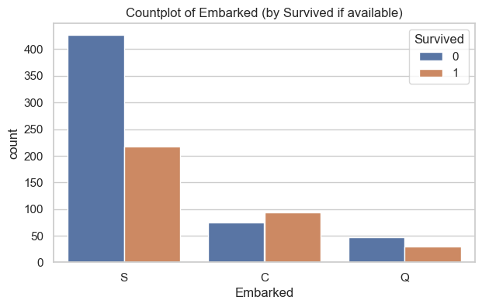

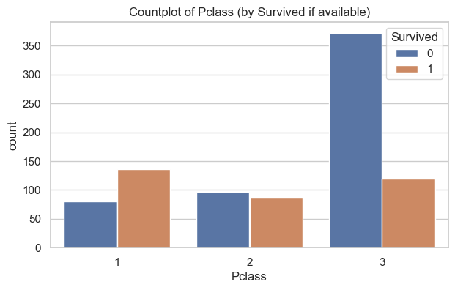

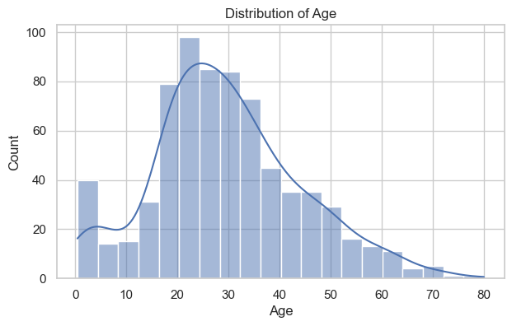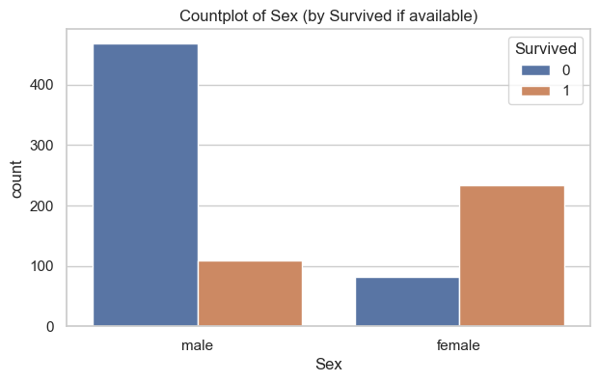

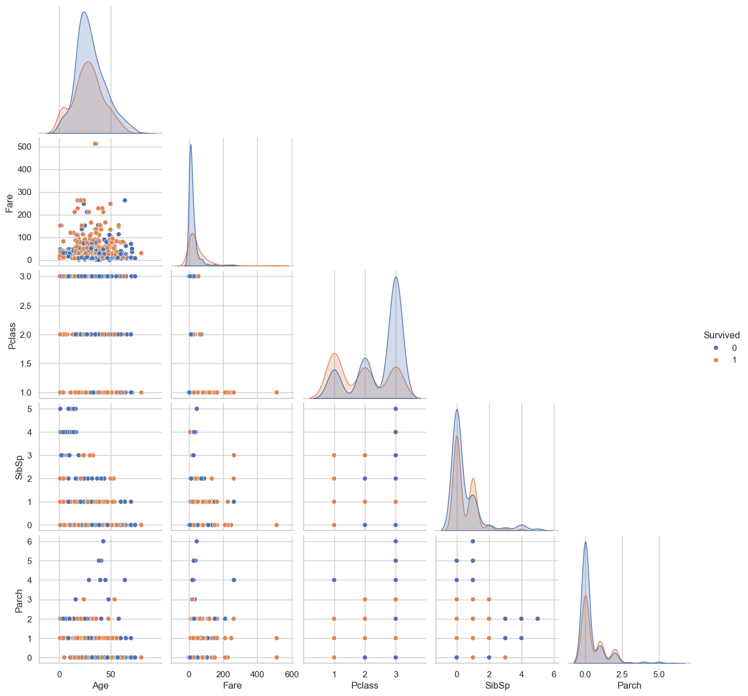

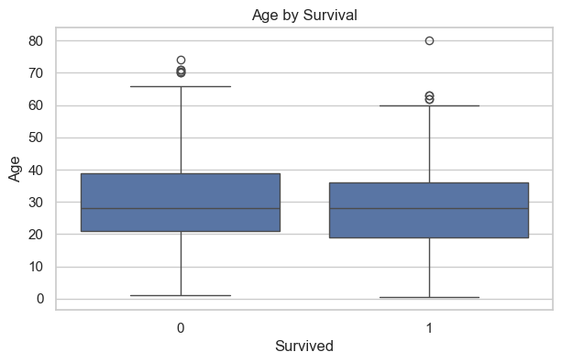

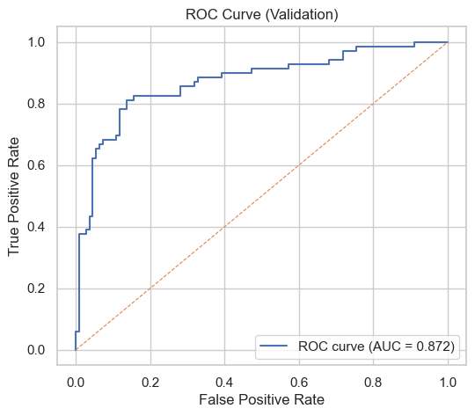

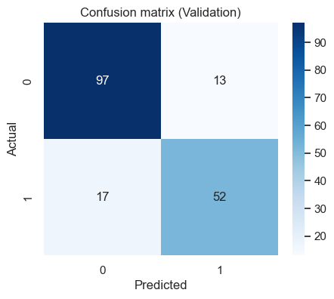

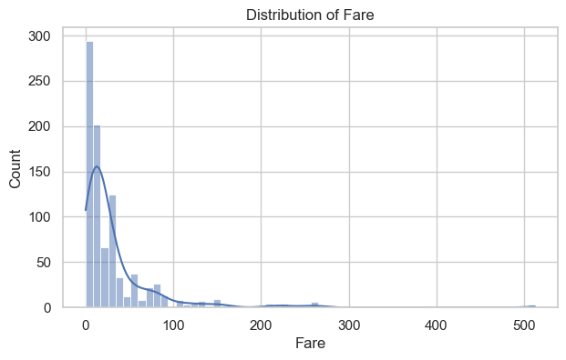

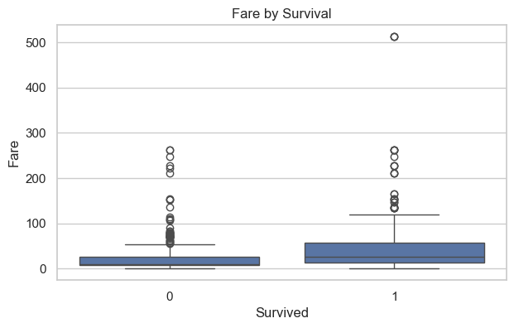

**5. Interpretation:**

**a. Interpret the coefficients of the logistic regression model.**

**Answer:**

**Interpreting the Coefficients**

**In logistic regression:**

* **Positive coefficient → increases survival probability (holding all else constant).**
* **Negative coefficient → decreases survival probability.**
* **Magnitude = strength of influence.**

**For example:**

* **If Sex_female has a strong positive coefficient → being female strongly increases the odds of survival.**
* **If Pclass=3 (3rd class) has a strong negative coefficient → being in 3rd class decreases odds of survival.**

**The model you trained extracted features like:**

* **Sex_male, Sex_female**
* **Embarked_C, Embarked_Q, Embarked_S**
* **Title_Mr, Title_Mrs, Title_Miss, etc.**
* **Pclass (numeric 1–3)**
* **HasCabin (0/1)**
* **Numeric standardized versions of Age, Fare, SibSp, Parch.**

**b. Discuss the significance of features in predicting the target variable (survival probability in this case).**

**Answer:**

### Significance of Features (Titanic Survival)

From many Kaggle/Titanic logistic regression runs, the usual pattern is:

1. **Sex**
   * female has the strongest positive impact (the “women and children first” rule).
   * male is the opposite → strong negative coefficient.
2. **Pclass (Ticket Class)**
   * 1st class passengers had much higher survival chances (positive influence).
   * 3rd class passengers much lower (negative).
3. **Title (from Name)**
   * Mr is usually strongly negative (most adult males did not survive).
   * Miss and Mrs positive (many women survived).
   * Rare titles vary — some officers or aristocrats fared better.
4. **Fare**
   * Higher fare = higher survival probability (proxy for wealth → better cabins, closer to lifeboats).
5. **Age**
   * Younger passengers slightly more likely to survive (but less strong than sex/class).
6. **HasCabin**
   * Having a recorded cabin number (1) often correlates with wealth/class → positive effect.
7. **Embarked**
   * Passengers from port C (Cherbourg) had higher survival odds than S (Southampton).

**A Narrative Wrap-Up**

**So, logistic regression “thinks” survival probability rises if you were:**

* **A female passenger,**
* **Traveling in 1st class,**
* **Paid a higher fare,**
* **With a known cabin,**
* **Holding a title like Miss/Mrs,**
* **Embarked from Cherbourg.**

**And survival plummets if you were:**

* **A male in 3rd class,**
* **With “Mr” in your name,**
* **Paid a very low fare,**
* **Had no cabin recorded.**

**Which matches history pretty well: the Titanic’s evacuation did prioritize women, children, and wealthy first-class passengers.**

**6. Deployment with Streamlit:**

**In this task, you will deploy logistic regression model using Streamlit. The deployment can be done locally or online via Streamlit Share. task includes creating a Streamlit app in Python that involves loading trained model and setting up user inputs for predictions.**

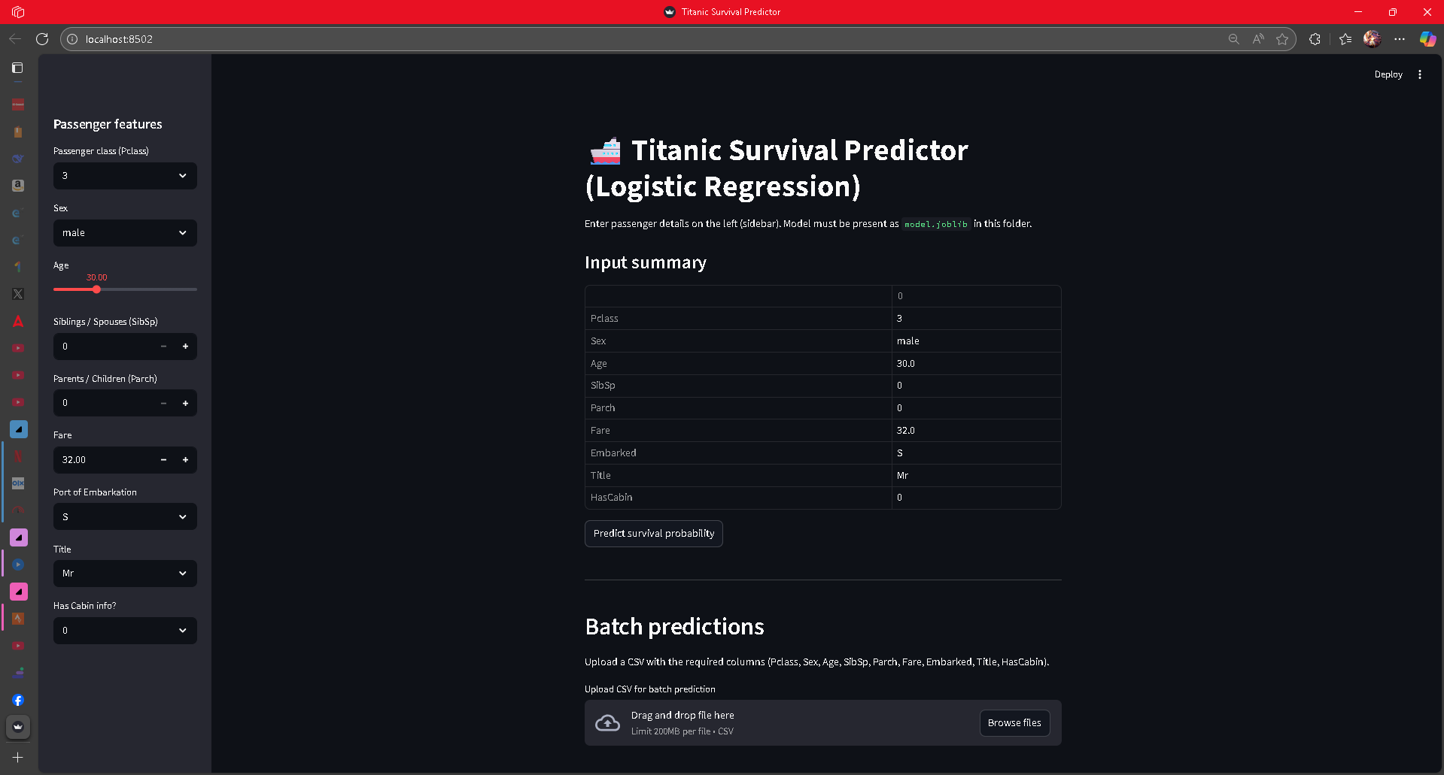

(optional)For online deployment, use Streamlit Community Cloud, which supports deployment from GitHub repositories.

Detailed deployment instructions are available in the Streamlit Documentation.

<https://docs.streamlit.io/streamlit-community-cloud/deploy-your-app>

**Interview Questions:**

1. What is the difference between precision and recall?

2. What is cross-validation, and why is it important in binary classification?